

**AMERICAN INTERNATIONAL UNIVERSITY–BANGLADESH (AIUB)**

**FACULTY OF SCIENCE & TECHNOLOGY**

**DEPARTMENT OF PHYSICS**

**PHYSICS LAB 2**

**Summer 2020-2021**

**Section: X, Group: 07**

**LAB REPORT ON**

***To determine the spring constant and effective mass of a given spiral spring***

**Supervised By**

**Dr. Md. Nurul Kabir Bhuiyan**

**Submitted By**

|  |  |  |
| --- | --- | --- |
| **Name** | **ID** | **Contribution** |
| **1. Md. Fahtin Emtiaz Onik** | **19-40471-1** | **Introduction, Discussion** |
| **2. Nafinur Leo** | **20-42195-1** | **Apparatus, Procedure** |
| **3. S.M. Ashikur Rahman** | **20-42833-1** | **Experimental Data Table, Graph** |
| **4. S.M. Hosney Arafat Rizon** | **20-43019-1** | **Result, Analysis** |
| **5. Rad Shahmat Sabit** | **20-43610-1** | **Calculation, References** |

Date of Submission: **August 08, 2021TABLE OF CONTENTS**

|  |  |
| --- | --- |
| **TOPICS** | ***Page no*.** |
| **i) Title Page** | 1 |
| **ii) Table of Content** | 2 |
| 1. **Introduction** | 3 |
| 1. **Apparatus** | 4 |
| 1. **Procedure** | 5 |
| 1. **Experimental Data** | 6 |
| 1. **Analysis and Calculation** | 8 |
| 1. **Result** | 8 |
| 1. **Discussion** 2. **References** | 9  9 |
|  |  |
|  |  |

**1. Introduction**

The restoring force, F, of a stretched spring is proportional to its elongation, x, if the deformation is not too great. This relationship for elastic behavior is known as Hooke's law and is described by

$$F=-kx(eq. 1),$$

where k is the constant of proportionality called the spring constant. The spring’s restoring force acts in the opposite direction to its elongation, denoted by the negative sign. For a system such as shown in figure 1, the spring's elongation, $x-x_{0}$, is dependent upon the spring constant, k, and the weight of a mass, mg, that hangs on the spring. If the system of forces is in equilibrium (i.e., it has no relative acceleration), then the sum of the forces down (the weight) is equal and opposite to the sum of the forces acting upward (the restoring force of the spring), or

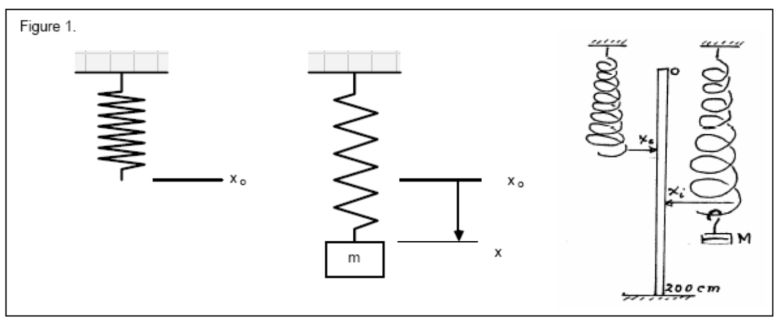 $mg=k\left(x-x_{0}\right)\left(eq. 2\right).$

Comparing equation 2 with the form for the equation of a straight line (y = mx + b), we can see that if we plot the force produced by different masses (mg) as a function of the displacement from equilibrium ($x-x_{0}$), the data should be linear and the slope of the line will be equal to the spring constant, k, whose standard metric units are N/m. If the mass is pulled so that the spring is stretched beyond its equilibrium (resting) position, the restoring force of the spring will cause an acceleration back toward the equilibrium position of the spring, and the mass will oscillate in simple harmonic motion. The period of vibration, T, is defined as the amount of time it takes for one complete oscillation, and for the system described above is:

$$T=2π\sqrt{\frac{m_{e}}{k}}\left(eq. 3\right).$$

where me is the equivalent mass of the system, that is, the sum of the mass, m, which hangs from the spring and the spring's equivalent mass, me-spring, or

$$m_{e}=m+m_{e-spring}\left(eq. 4\right).$$

Note that me-spring is not the actual mass of the spring, but is the equivalent mass of the spring. It is not the actual mass because not all of the mass pulls down to act in concert with the weight pulling down. Its theoretical value for our system should be approximately 1/3 of the actual mass of the spring. Substituting equation 4 into equation 3 and squaring both sides of the equation yields:

$$T^{2}=\frac{4π^{2}}{k}(m+m_{e-spring})$$

Expanding the equation:

$$T^{2}=\frac{4π^{2}}{k}m+\frac{4π^{2}}{k}m_{e-spring}\left(eq.5\right).$$

Therefore, if we perform an experiment in which the mass hanging at the end of the spring (the independent variable) is varied and measure the period squared (T2; the dependent variable), we can plot the data and fit it linearly. Comparing equation 5 to the equation for a straight line (y = mx + b), we see that the slope and y-intercept, respectively, of the linear fit is:

$$slope= \frac{4π^{2}}{k} and y-intercept=\frac{4π^{2}}{k}m_{e-spring} \left(eq.6\right).$$

**2. Apparatus**

(1) A spiral spring

(2) A set of weights

(3) A weight hanger

(4) A balance

(5) A stop watch

(6) A two-meter stick

**3. Procedure**

**Part I: Determination of the spring constant by Hooke’s law:**

(1) A two-meter stick with zero was ended on the top and the 200 cm (2 m) was ended on the floor (as shown in figure 1). The position of the last coil of the freely hanging spiral spring was read and it was recorded on our data sheet as x0.

(2) An approximate 0.150 kg mass was hung to the spring. The mass of the hanger and weigh the masse on a balance was included. This mass was recorded in column 1 on our data sheet for part I.

(3) In column 2 on the data sheet, the weight of the mass was calculated using F = mg, where m was in kg and g was 9.8 m/s2.

(4) The position of the same last coil of the spring as in step 1 (shown in figure 1) was read xi. This distance in column 3 was recorded on our data sheet for part I.

(5) In the fourth column on the data sheet, the total displacement of the last coil of the spring was calculated, Δx = xi – x0.

(6) After that, steps 2-5 for masses was repeated approximately equal to 0.200 kg, 0.250 kg, 0.300 kg, 0.350 kg, and 0.400 kg.

(7) For this graph, six data points was used. The five data pointswas used for each of the five masses and an additional data point was used at (0,0). This data point was valid because when 0 kg was hung on the spring, it was displaced 0 m from its equilibrium position.

(8) The data with a linear function was fit in the form of y = mx + b and it was determined the value of the spring constant from the slope of the best-fit line.

**Part II: Determination of the spring constant by its period of oscillation in response to different masses:**

(1) The spring on a balance was weighed. Its mass was recorded on our data sheet.

(2) An approximate 0.150 kg mass from the spiral spring was hung. The actual mass on our data sheet for part II was recorded.

(3) The oscillation in a vertical direction was started by pulling gently down on the mass and released it (an initial displacement of 2-3 cm works best) and measured the amount of time required for twenty complete oscillations with a stop watch and recorded it as t1 on our data sheet.

(4) Step 2-3 three times was repeated. It was found the average and recorded this as tavg on our data sheet.

(5) The system's period for one oscillation was divided tavg by 20 and was recorded this on our data sheet.

(6) It was repeated steps 2-5 for masses approximately equal to 0.200 kg, 0.250 kg, 0.300 kg, 0.350 kg, and 0.400 kg.

(7) The values of T2 was calculated. It was recorded in the appropriate column on our data sheet.

(8) A graph of T2 vs. mass, m was made. There were only six data points for this experiment. There was no (0,0) data point because a mass of 0 kg was produced no oscillatory motion.

(9) The data with a linear function in the form of y = mx + b was fit.. The values for the slope and y-intercept was correspond accordingly to the relationships given by equation 6.

(10) The value of the spring constant was determined (in dyne/cm) from the slope.

(11) The value for the equivalent mass of the spring, me-spring, was determined from the value of the y-intercept and the value of k found in step 10.

(12) The percent difference between k in part I and k in part II was found.

(13) The ratio of the equivalent mass of the spring to the total mass of the spring was found. It was weighed (me-spring/mspring).

**4. Experimental Data**

(A) Length of the spring, L = 28.5 cm

(B) Determinations of extensions and time periods:

**Table: Determinations of extensions and time periods:**

|  |  |  |  |  |  |  |
| --- | --- | --- | --- | --- | --- | --- |
| **No. of**  **Obs.** | **Loads**  **Mo (gm)** | **Extension**  **L(cm)** | **No. of**  **Vibrations**  **n** | **Total time**  **t (s)** | **Period**  **T = t / n**  **(s)** | **T²**  **(s2)** |
| 1 | 150 | 8.5 | 20 | 13 | 0.65 | 0.4225 |
| 2 | 200 | 12 | 20 | 15 | 0.75 | 0.5625 |
| 3 | 250 | 15 | 20 | 17 | 0.85 | 0.7225 |
| 4 | 300 | 18 | 20 | 18 | 0.9 | 0.81 |
| 5 | 350 | 21.5 | 20 | 20 | 1 | 1 |
| 6 | 400 | 24.5 | 20 | 21 | 1.05 | 1.1025 |

**5. Analysis and Calculation**

(1) From L vs Mo graph,

y = 0.0637x - 0.9381 where, slope = 0.0637

Now,

$$slope=\frac{4π^{2}}{k} \\ k=\frac{4π^{2}}{slope}$$

$$k= \frac{4π^{2}}{0.0637}$$

$=619.76 dynes/cm$

(2) From T2 vs Mo graph,

y-intercept = 0.4225

Now,

$$y-intercept=\frac{4π^{2}}{k} m_{e-spring }$$

$$m_{e-spring }=\frac{y-intercept *k}{4π^{2}}$$

$$m_{e-spring }=\frac{0.4225*619.76}{4π^{2}}$$

$$=6.633 gm$$

**6. Result**

The spring constant, k = 619.76 dynes/cm

Effective mass of the given spiral spring, me-spring = 6.633 gm

**7. Discussion**

The purpose of the experiment is to determine the spring constant and effective mass of a given spiral spring. The value of spring constant is 619.76 dynes/cm. The value of effective mass of the given spiral spring is 6.333 gm.

(1) The spring constant, k = 619.76 dynes/cm and Effective mass of the given spiral spring, me-spring = 6.633 gm.

(2) Some instrumental error was aroused.

(3) It was coincided with circular scale zero.

(4) The weights were hung along the axis of spring.

(5) Measurement of time period was not appropriated due to personal observation error.

(6) Oscillations were occurred in vertical plane but it was occurred little in a horizontal plane also.

**8. References**

*(i) Fundamental of physics: Resnick & Halliday*

*(ii) Practical physics: R. K. Shukla, Anchal Srivastava, New Age International (p) ltd,New Delhi*

*(iii) Zemansky, M.W. (1968) Heat and Thermodynamics*